**Barber/hairdresser shop website**

## **Analysis**

### Description

My plan is to create an interactive website which allows users to discover, book and rate local hairdressers and barbers within Bristol. My website will be aimed at both male and female customers looking to have a haircut and will make the process of booking a place far easier and quicker. The website will be linked to a data base which will store data important to the shops as well as the customers which will benefit both stakeholders the customers and the actual shops.

### Stakeholders

My website will reach a wide variety of people of pretty much any age and any gender. The website will therefore have to be attractive universally and appeal to a large percentage of the population. However, even though the website will be accessible for any age group, the main target audience will likely to be in an age range of about 16-35-year olds due to keen interest in looking there best at this age and their advanced knowledge of using technology. However, even though the website will be mainly used by a younger age group the website will be made very user friendly and appealing that it will also be extremely accessible to an older clientele as previously stated.

The other obvious stake holder would be the actual barber and hair dresser shops. The website with a large user base would be extremely beneficial to a small and even established company, as it would allow them to promote themselves to an extremely targeted market for a percentage of their trade received. This would not only help grow the shops but also allow new customers to discover shops that customers would have never even thought about going to without the website. Also, the website can be used by the barber/hairdresser shops as their market research making it easier to see where they are going wrong if they aren’t getting a lot of business but also, to see if they are charging the correct price for their service compared to other shops in the surrounding area.

The website would also create communication between all the stakeholders and the end-users as the data base will store contact details which could easily be accessed by the customer and the shop. This would benefit both stakeholders as if a customer needs to cancel it saves the shop money as they can get another customer but also, allows the customer who cancelled to book another appointment.

### Computational Method

The website will be programmed in HTML and will use java script to make it interactive and dynamic. A data base will also be used to store personal data about customers and shops as previously stated and this will be done using SQL.

A new customer to the website will have to make an account with the website which will ask for data such as name, address, contact information (email and phone number) and a password to login. This will be then stored in the database and will be used by the shop if required.

Once an account has been made, the website will have a main page which will allow the user to input whether they want to look for either a barber shop, hairdresser shop or both within Bristol. Once the user is happy to proceed, they will be able to click search and a list of a shops will appear with their rating and address. Each shop will be interactive and allow users to click on them to see more details. From this stage users can book an appointment which will alert the shop and tell them that they will have a customer coming to the shop and will also receive contact information of the customer.

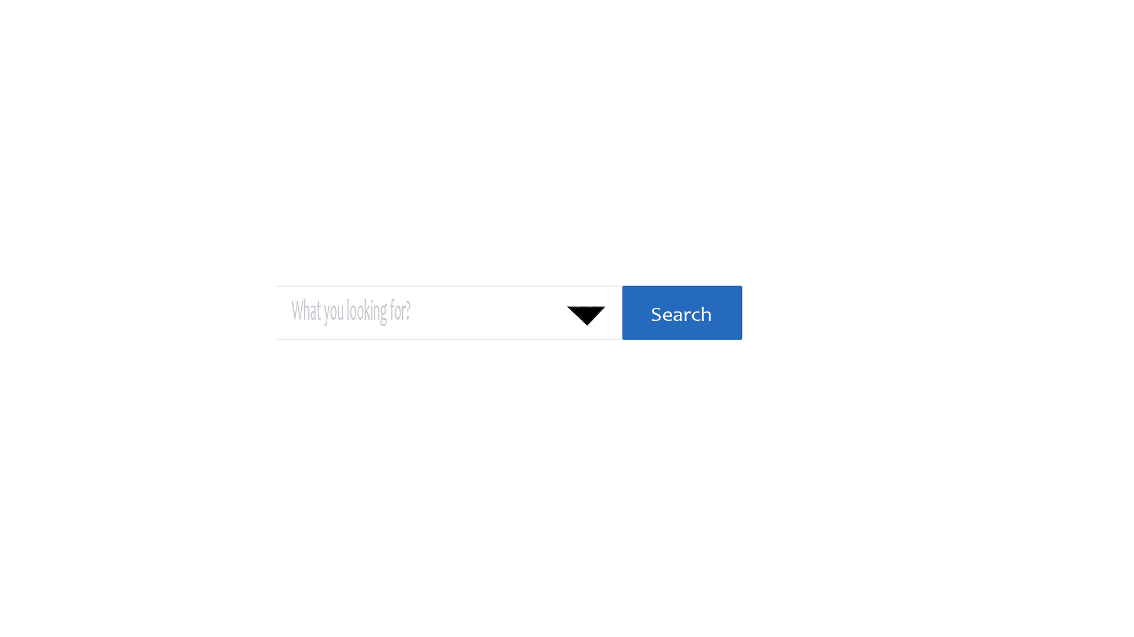

Example above of drop-down box where users can select weather, they are looking for a barber, hairdresser or both

I believe a website like this is necessary because in an age of technology I believe something like having a haircut which everyone has could be made far simpler and user friendly and we have seen this is similar modules where it has worked extremely well for example just eat for takeaways and uber for taxis.

### Research

The website module is very similar to that of just eat. Just eat allows users to order food from multiple takeaways within their area which then notifies the takeaway shop to make an order. This is extremely like my website which allows users to search for Barber/hairdresser shops within Bristol and then book an appointment with the shop to have a haircut. Not only this, there doesn’t seem to be any competition in this field which would cause a threat and there for would be a perfect solution to fill a gap in the market.

### Interview with a local barber

I discussed my website with a local barber where I usually get my haircut and he was willing to give me some feedback of what he thought of my proposed solution. I asked him about why he doesn’t use a booking system and his response was very simple it was too time consuming. He said as an owner of a barber shop doing finances, cutting hair and answering calls would just be too much. However, he said if he could have some sort of customer booking system in place it would be extremely beneficial to his business as it would spread out the amount of traffic coming to his store throughout the day and not just get times when the store is packed and other times it is empty.

The other feature of the proposed solution he really thought would be a good idea was the review system as he said it would be rewarding to him if he got a good review from his customer which would suggest to him, he’s done a good job. Not only this, he liked the fact that it would lead to more business if he had a lot of good reviews which for a small business would be huge.

Overall, he seemed extremely impressed with the idea of the solution and felt that if the website was done to a good standard it would be a good and effective solution to a gap in the market.

### Key features of the proposed solution

**User Login dates will be stored in database**-This will Monitor a user’s usage of the website which is important to retain clientele. The system will work by using a simple script which will then send an email to the user who hasn’t logged on for a period. The way of doing is through an api like mailchimp.com which will use data from a database like MYSQL and send an email to the user who hasn’t been active.

**Logins to database and website to be secure-** The website will require the user to input their username and password to use the site. This will be encrypted to protect the user’s login details to people picking up packets on a public connection if ever this was the case. Also, the website will have two separate types of users-Normal users and Admins. Admins will have access to information stored within the database whereas, users will not to protect information.

**Integrated google map-**Directions to the actual barber/hairdresser shop is important for a user to know how to get there. Therefore, my website will have a map linked to each shop. I will do this by adding an API key link on my HTML page which should give me a map and marker of my choice. More information- https://developers.google.com/maps/documentation/javascript/adding-a-google-map

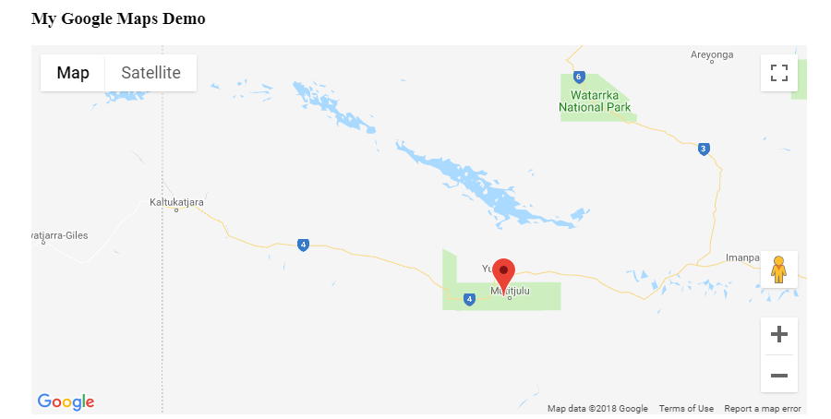

Above an example of integrated google map

**A review system for users to input their thoughts on a shop-**This would allow users to see how others felt with their experience at a shop and then make a choice off these results. This could be made possible with a third-party software like google reviews ,review buddy or cackle they can be found here-

google reviews <https://support.google.com/business/answer/3474122?hl=en-GB>

review buddy-https://www.reviewbuddy.com/

cackle -http://cackle.pro/reviews .

### Limitations

My original idea was to create a website where anyone in the country could insert the postcode of where they wanted to such for a hair dresser/barber shop and be listed a set of shops they could use. However, this would be completely unfeasible /unachievable so instead I have narrowed it down to just one area/city which is going to be Bristol.

One limitation of my proposed website is that I won’t have any legit users/shops therefore I will have to test run the website with made up shops. However, even though this will be the case it will still prove whether the module works or not.

### Software and hardware

A user must be on a device which has access to the internet has a cache and has a web browser installed on it. However, nowadays nearly every device can do this, these include-smart phone, tablets, pc’s, smart tv’s and even games consoles.

### Success Criteria

My website will be a real challenge to produce but I feel is an achievable feat. However, I believe there are some essential features that my website will require for it to function basically and also some less essential features which will make the web experience more enjoyable but won’t be necessary.

**Important:**

**Logins to database and website to be secure-** The website will require the user to input their username and password to use the site. This will be encrypted to protect the user’s login details to people picking up packets on a public connection if ever this was the case. Also, the website will have two separate types of users-Normal users and Admins. Admins will have access to information stored within the database whereas, users will not to protect information.

**Integrated google map-**Directions to the actual barber/hairdresser shop is important for a user to know how to get there. Therefore, my website will have a map linked to each shop. I will do this by adding an API key link on my HTML page which should give me a map and marker of my choice. More information- <https://developers.google.com/maps/documentation/javascript/adding-a-google-map>

*This is an important feature as it allows users to locate shops with real ease and even though it may not be completely essential for the website to run it is a real simple and tidy feature to add.

**Less essential:**

**User Login dates will be stored in database**-This will Monitor a user’s usage of the website which is important to retain clientele. The system will work by using a simple script which will then send an email to the user who hasn’t logged on for a period. The way of doing is through an api like mailchimp.com which will use data from a database like MYSQL and send an email to the user who hasn’t been active.

## Design

### Decomposing the Problem

For each different page of my website I will create a new page/file of code. This will help me as I will be able to edit each page of my website easier as I will know where to look if there is a problem but also, it will allow me to add features in future with ease if after testing I feel that something may be missing/improved.

I will also produce a separate PHP sheet and link it to the page which it is taking inputs which will then store it to the database. Below is a flow chart that shows how a user can log into the website or create an account for my website.

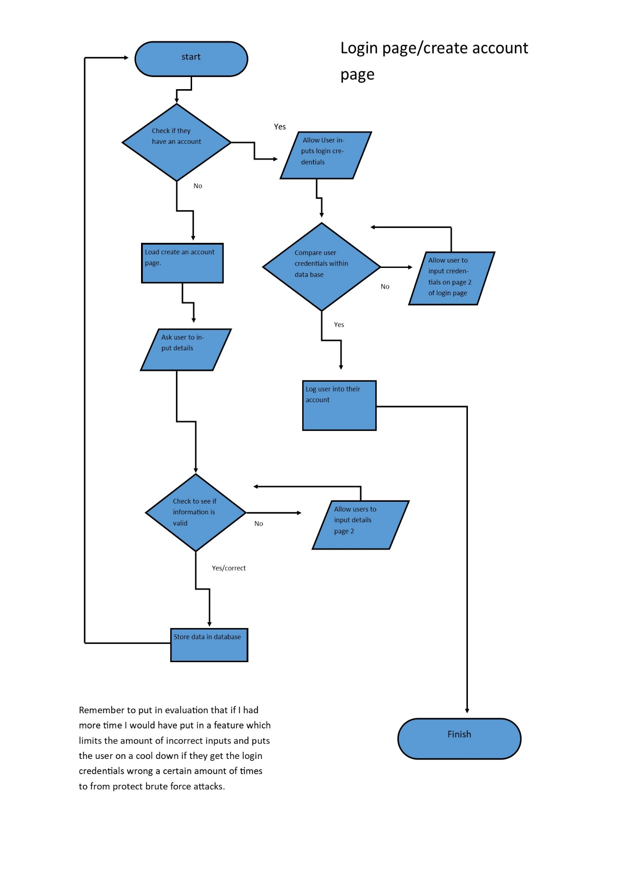

Homepage

I plan for my homepage to be extremely attractive and user friendly. I will start off by having a sign in button in the top left of the screen which will redirect a user to the login page of my website. This page will allow users to enter their details which will then be checked against the data base to see where or not the details are correct or if they don’t have an account create one. More details on this are in section (Decompose the problem- Login page).

The homepage will allow the user to select their gender by clicking an image of a male or female avatar. Depending on which avatar they select it will then redirect them to either barbers (male avatar) or hairdressers (female avatar) around Bristol.

In the footer of my website I will integrate a review system. This will allow customers to voice their opinions of the website and help new clients decide whether they want to use my website. To achieve this, I am planning on using a third-party review system such as cackle which can be found here-http://cackle.pro/reviews .

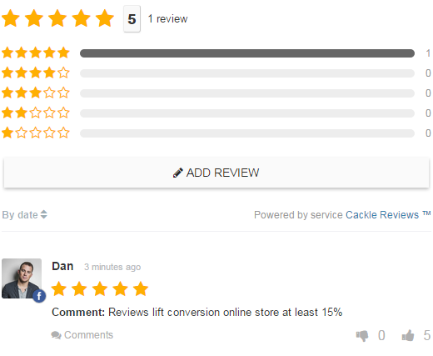

Above an example of cackle which allows user to input their experience of a service

Login page

Once a user has clicked on the login button on the homepage, they will be redirected to the login page of my website. Here they will be able to login to an existing account or create one.

How the problem will be broke down if they –

* Have an account- If a user already holds an account with the site, they will input their user name and corresponding password then click the sign in button. At this stage the user’s input will checked against the correct username and password within the sites database (using php) and if correct log the user in and return them to the logged in homage for either a customer or business more in (decompose problem- customer and business page). In a case of an error with the details inputted, the website will output a red coloured message stating ‘username or password incorrect please try again’. The user will then be allowed to input their details again due to the probable mistake though, my plan is to put a limit on the amount of attempts a user can have to prevent brute force attacks on the site.
* Don’t have an account- In an event of a user not having an account created with the site, the login page will have a create an account button. This button will allow a user to input personal information into a form with things like- Username, password, DOB, Email, and Name. The form will be checked using a form validation system so a user can’t give invalid information.

“ADD FLOW CHART OFF LOGIN PAGE”

Barber or hairdresser page

After a user has choose their gender and arrived on either the barber or hairdresser page, they will be presented with a list of shops around Bristol with each having a small synopsis of where they are located and a star rating and a picture of the premises. The user will then be able to find out more by clicking on their desired shop where full details of the store will be shown and an integrated google map of the location will be on display for the user.

### Structure of the solution

### Algorithms

### Usability features

### Key variables and structure

### Test data for development

### Test data for beta testing

## Development

### Iterative development

### Prototyping

### Annotated modular code

### Validation

### Reviews

## Evaluation

### Testing

### Usability features

### Evaluation

### Maintenance